# St. Stanislaus Bishop & Martyr

**Roman Catholic Church**

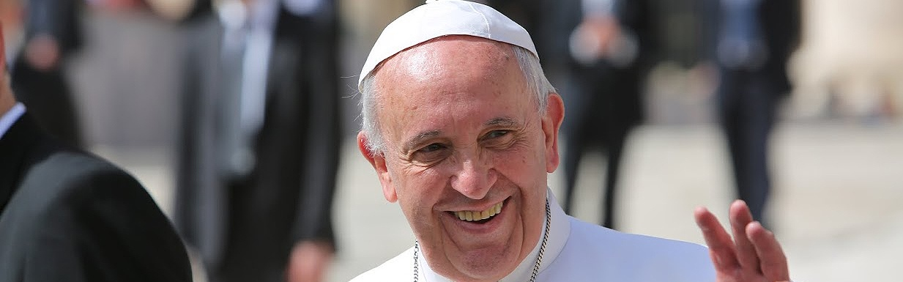

**Pope Francis in America**

**Papież w Ameryce**

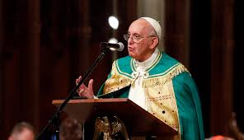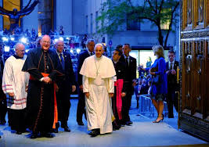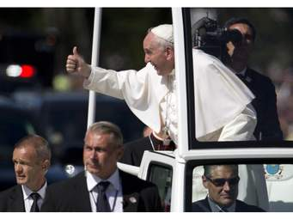

**Priests**

**of the Congregation of the Mission**

**Księża Misjonarze**

***Fr. Tadeusz Maciejewski, C.M. Pastor***

***Fr. Anthony Kuzia, C.M. Parochial Vicar***

***Fr. Stanley Miękina, C.M. Vicar Emeritus***

**Office /Rectory**

**9 ELD ST. NEW HAVEN CT 06511**

**TEL.: 203-562-2828 FAX:203-752-0217**

**Anointing of the Sick/**

**Namaszczenie Chorych**

***Call the parish office***

**Baptism – Sundays 12:30 PM**

**Marriage Arrangements**

***Six months in advance / Fr. Anthony***

**Confession Spowiedź**

**Mon.- Sat. 7 AM – 7:30 AM**

**Saturday 3:30 PM – 4:15 PM**

**Sunday Mass Schedule**

**Sat. 4:30 PM English**

**Polish 7:30 AM & 11:30 *AM***

**English 9:00 AM & 10:15 AM**

**Latin 2:00 PM**

**Monday – Saturday**

**English 7:00 AM,**

**Polish 7:30 AM**

**Kancelaria Parafialna Czynna – Parish Office**

**Tuesday- Friday 9:00AM - 4:00PM**

**†**

**THE TWENTY-SEVENTH SUNDAY IN ORDINARY TIME OCTOBER 4, 2015**



***Anticipated Sunday Mass***

**4:30** **PM** †Cecelia & Henry Soleski & John Keane *by the*

*Soleski Family*

**SUNDAY** **OCTOBER 4TH  THE TWENTY-SEVENTH SUNDAY IN ORDINARY TIME**

**7:30** **AM** W intencji Parafian

**9:00** **AM** †Elmer & Lillian Edwards *by the Gwardyak Family*

**10:15** **AM** †Rola & Kennedy Families *by Family*

**11:30 AM** †Gerald Panagrosso, *int. od Jana i Teresy Jasinkich*

**2:00 PM** Propria

**MONDAY OCTOBER 5TH**

**7:00 AM** †For the Deceased Members of the Congregation of

the Mission

**7:30 AM** †Za dusze w czyśćcu cierpiące

**6:30 PM Adoration of the Blessed Sacrament & Rosary**

**Devotion**

**7:00 PM Miraculous Medal Novena & Benediction**

**TUESDAY OCTOBER 6TH**

**7:00 AM**  Blessings for Kaylea on her seventeeth birthday *by*

*family*

**7:30 AM** †Za dusze w czyśćcu cierpiące,*int od N. Torello*

**WEDNESDAY OCTOBER 7TH OUR LADY OF THE ROSARY**

**7:00 AM** In honor of Our Lady *by Mary C.Welborn*

**7:30 AM** † Za zmarłych Księży i Braci Zgromadzenia Księży

Misjonarzy

**THURSDAY OCTOBER 8TH**

**7:00 AM** † For the Decesed Priests and Brothers of the

Congregation of the Mission

**7:30 AM** † Za zmarłych Księży i Braci Zgromadzenia Księży

Misjonarzy

**FRIDAY OCTOBER 9TH**

**7:00 AM** †Deceased of the Zoni Family *by Frank Zoni*

**7:30 AM** †Dorothy Far *& Marian Chrostek od Elizabeth*

*Manieri*

**7:00 P.M. NABOŻEŃSTWO RÓŻAŃCOWE**

**SATURDAY OCTOBER 10TH**

**7:00 AM** Blessings for Fr. Roman Kmieć, C.M. *by Mary C.*

*Welborn*

**7:30 AM** † Za zmarłych Księży i Braci Zgromadzenia Księży

Misjonarzy

***Anticipated Sunday Mass***

**4:30** **PM** †Sister Dolores Nurczyk,C.S.F.N. *by sister*

**SUNDAY** **OCTOBER 11TH  THE TWENTY-EIGHTH SUNDAY IN ORDINARY TIME**

**7:30** **AM** †Stanisław Ropiak *int. od rodziny Wiśniewski*

**9:00** **AM** For the Intention of the Holy Name Society

**10:15** **AM** †Deceased members of the Kerr, Prusaczyk &

Szymański Families  *by Barbara Prusaczyk Kerr*

**11:30 AM** †Za dusze Św. Pamięci moich Siostr Marianny

Hałasa i Jej Męża Jana, Weroniki Gwiazda i Jej

Męża Józefa oraz Ireny Milczyńskiej oraz za

Zmarłych całej rodziny Guzowskich, int. od

Krystyny Guzowskiej

**2:00 PM** †Henry Korczyński Sr., Henry Korczyński Jr. &

Linda Korczyński



**The Sanctuary Lamps Burn**

**for a Special Intention**

** 26th/27th - Regular Offertory –2536.50.**

**Catholic Grammar School Collection –**

**$1055.00.**

There are two collections today. The second collection is

for the repair of Church buildings. Dzisiejsza druga składka przeznaczona jest na naprawy budynków kościoła.

The following donations have been made in the office this week: $2000.00 – N.N.; $300 – Joseph, Beverly & Katarzyna Zadroga & Józefa Badurek for tower repair, $50 – Paul & Diane Wisnafski in memory of Roman Gensicki; $50 - Donald, Lori & Brad Stowe & Hattie Górski for tower repair.

**St. Stanislaus Religious Education**

**There will be NO Religious Education Classes on Saturday, October 10th. Classes will RESUME on Saturday, October 17th at 9 A.M.**

**Religious Education Teachers will meet on Saturday, October 17th from 10:15 A.M. till 11:15 A.M.**

**FAITH FORMATION**

**Our goal as a parish is to ensure that all our children are afforded an opportunity to attend regular formation classes at St. Stanislaus. Classes take place on Saturday mornings from 9 A.M. till 10:15 A.M. in the school. If your child does not already participate, you are invited to stop by the parish office for a registration form. For more information, please call Fr. Anthony at 203-562-2828.**

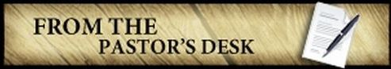Dear Parishioners,

With all my heart I wish to thank all for participating in the Parish Picnic this Sunday. I want especially to thank those who dedicated their time to preparing the Parish Picnic. It is undoubtedly because of your efforts that this year’s Picnic was a success. I am also convinced that your efforts on this Picnic contributed to deepening our relationships and to making our parish community a parish family.

While thanking you for your time and dedication, I assure you that I shall remember you in my prayers.

These are my first weeks in the Parish, therefore, I also want to thank my dear parishioners for the warm welcome I have received. I wish to assure you that I shall do everything to make our Parish grow spiritually and in numbers.

May the good God strengthen us in our trials and as he makes our Parish grow may we be under His care and may He bless us.

Fr. Tadeusz

**†**

[](http://www.newsletternewsletter.com/searchart/ImageDetail.asp?image_id=95100712) **DWUDZIESTA SIÓDMA NIEDZIELA ZWYKŁA 4 PAŹDZIERNIKA 2015**

*Kochani Parafianie,*

*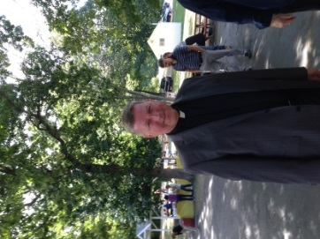Z całego serca pragnę podziękować wszystkim za udział w niedzielnym Pikniku. Słowa szczególnej wdzięczności pragnę wyrazić tym, którzy poświęcili swój czas i zaangażowali się w przygotowanie naszego parafialnego święta. To dzięki Wam tegoroczny Piknik z całą pewnością uznać można za udany. Przekonany jestem, że przyczynił się on również do pogłębienia wzajemnych relacji, a tym samym uczynienia naszej wspólnoty parafialnej, wspólnotą rodzinną.*

*Dziękując z głębi serca za czas i poświęcenie zapewniam o mojej szczególnej pamięci w modlitwie.*

*Ponieważ są to moje pierwsze tygodnie w tej Parafii, stąd też, raz jeszcze pragnę podziękować Wam wszytkim Kochani Parafianie za miłe i serdeczne przyjęcie. Zapewniam, że uczynię wszystko, by nasza Parafia wzrastała nie tylko duchowo, ale rówbież liczebnie.Niech dobry Bóg w naszym wzajemnym trudzie umacniania i rozwijania naszej wspólnoty parafialnej ma nas w swojej opiece i nam błogosławi.*

*Ks. Tadeusz*

**Dar małżeństwa**

Jedność kobiety i mężczyzny w związku małżeńskim jest wpisana w Boży plan zbawienia. Im bardziej dwoje ludzi jest zjednoczonych ze sobą, tym bardziej Bóg zostanie uwielbiony. Życie małżeńskie jest jedną z form powołania chrześcijańskiego. Przeżyte dobrze prowadzi do świętości. Naturalnym owocem małżeństwa jest potomstwo. Bóg obdarza małżonków dziećmi, powierzając im odpowiedzialność za ich dobre wychowanie. Gdy pojawi się kryzys w małżeństwie, nie ulegajmy zbyt szybko pokusie rozstania. Szukajmy pomocy w grupach wsparcia, kursach, rekolekcjach i na modlitwie. Bóg pobłogosławił wasze małżeństwo w dniu ślubu, a teraz będzie was ochraniał i wspomagał.   
***Panie, polecam wszystkie małżeństwa, które przeżywają trudne chwile i kuszone są wizją rozwodu. Ochraniaj je i wspieraj swoją mocą.***

*Rozważania zaczerpnięte z „Ewangelia 2015”*

[](http://www.newsletternewsletter.com/searchart/ImageDetail.asp?image_id=95100712)Marriage: God created man and woman to live for the good of each other. When two people are married they love and care for one another. Catholics believe that the love and friendship that is shared between husband and wife is a sign of God’s love. That is why marriage is a sacrament. All of creation reflects God’s love. The birds of the air and animals of the fields show us the beauty of God’s work. Man and woman were created as partners. We believe that God wants us to live together in friendship and love. When we do that, God’s love is made known throughout the world. (The Church believes that some marriages do not represent the kind of intimate union between two people that God intended at the beginning of creation. Therefore an annulment can be granted to those divorced couples whose marriage was never a sacramental marriage.)

**HOSPITALITY MINISTRY**

Today the Church calls for full, conscious and active participation by all of the faithful. Hospitality Ministers [Ushers, Collectors and Greeters] assist in creating an atmosphere which encourages members of the community to participate in the liturgy as fully as possible. Because St. Stanislaus Church is our Parish home, Hospitality Ministers should extend the welcome of the faith community just as a host or hostess would welcome visitors to their home. Just as a host would be very familiar with their home and all that is in it, Hospitality Ministers should be aware of the appointments of the Church and their functions. In this way, they are able to offer valuable assistance to those who come to St. Stanislaus Church for the celebration of the sacraments. On October 24th from 9:00 to 10:15, Father Anthony will be presenting a program on this important ministry. Ushers and Collectors are encouraged to attend. All are welcome to join the Hospitality Ministry at St. Stanislaus Church. Those who are interested should attend the presentation. If you are unable to attend, please contact Father Anthony at the rectory office.

*Raffle winners were as follows:*

|  |  |
| --- | --- |
| 1st Prize | D.LEWANDOSKI |
| 2nd Prize | MARIA.RAMOS |
| 3rd Prize | JUDITH LEE |
| 4th Prize | JÓZEFA BAHUNEK |
| 5th Prize | SCOTT ROTTINGHAUS |
| 6th Prize | BOGDAŃ.KADLOF |
| 7th Prize | MARIA.RAMOS |
| 8th Prize | ROSE.POLLACK |
| 9th Prize | HELENA.NOVAK |
| 10th Prize | JANET BARBLIS |
| 11th Prize | JANET.BURBLIS |
| 12th Prize | HALINA STOPKA |
| 13th Prize | ANNE MARNIK |
| 14th Prize | KATELYN ROPIAK |

**LADIES SOCIAL CLUB**

The members of the Ladies Social Club will hold a breakfast meeting on Friday, October 9th at 9 A.M. at the 91 Diner Restaurant**.**

**WANTED:**  Job taking care of elderly. CNA with references. Call 203-640-0090.

**Mark C. Gersz**

**Attorney At Law**

**GENERAL PRACTICE OF LAW**

**Wills۰ Probate۰ Closings ۰Personal Injury**

**203-488-8683**

**1 South Main St. Branford, CT**

LUPINSKI FUNERAL HOME

Angeline Iovanne Donna M. Lewandoski

Directors

821 State St. New Haven CT

203-865-4205

**Robert P. Kowalczyk**

***-Attorney At Law -***

**395 Orange St.**

**New Haven**

**203-865-6414**

***“Famous Brick***

***Oven Apizza*”**

**203-776-5306**

**MODERN APIZZA**

**874 State St. New Haven**

**1934**



C O A S T L I N E

***HEATING ۰ COOLING ۰PLUMBING***

Specializing in Oil & Gas Boilers, Furnaces & Water Heaters

**License #S7-308515 ۰ P-I 283661 ۰ Fully Insured**

**Shawn H. Freel 203-671-1267 Tom Boroczky**

***EAST ROCK DENTAL***

**James J. Bednarczyk, D.M.D.**

**Regina A. Niekrash, .M.D**.

*Mówimy po polsku!*

*65 Anderson St. New Haven,*

*Ve Ct.*

*ww www.eastrockdental.com*

***(203)-777-8436***

**

**Maria Nowak Byrne M.D**.

***Southern New England***

***Ear, Nose, Throat....***

**New Haven**

**203-777-1932**



[](http://www.oppeace.org/)

[www.oppeace.org](http://www.oppeace.org)

Join us!

For more info, contact Sr. June Fitzgerald, OP

[jfitzgerald@oppeace.org](mailto:jfitzgerald@oppeace.org) or 570-336-3991

**St. Stanislaus Church  
 Holy Name Society est. 1951**  **Accepting New Members**

**Contact Paul Broniek**

**203- 907- 2577**

**Rectory 203-562-2828**

Visit our website

at: www.sshns.org for more info.

Visit our website www.sshns.org



**PARISH MEMBERSHIP:**

Registering at St. Stanislaus BM Church is the foremost expression of your commitment to being part of our parish community. Being a registered parishioner also makes the process much simpler when it’s time to receive sacraments, register for religious education, to be entitled to the parish or the Hartford Archdiocesan tuition offered at a Catholic school for parish-registered Catholics, to sponsor a sacrament recipient, or even to plan church ministries. Church law no longer limits parish registration within particular boundaries. Make your commitment to St. Stanislaus BM Church, REGISTER!

**PRZYNALEŻNOŚĆ DO PARAFII:** Zapisując się do parafii dajesz wyraz poczucia przynależności do lokalnej społeczności kościoła, św. Stanisława BM, oraz ułatwiasz sobie i duszpasterzom udzielenia posługi sakramentalnej jak np: chrztu, ślubu, zapis na katecheze, otrzymanie pomocy finansowej w szkole katolickiej z parafii i z diecezji Hartford, czy otrzymanie prawnego zaświadczenia w różnych celach urzędowych, oraz planowanie duszpasterskiej posługi.

**PARISH REGISTRATION**

**NAME _________________________**

**STREET _________________________**

**CITY _________________________**

**PHONE _________________________**

**New Registration  Moving out **

**Change of address  Want Envelopes **

*Please let us know if you move out of or into the parish. Thank You.*

***Yearly Parish Dues/Parish Membership:***

**$10 Single $20 Family**



***We’re Celebrating***

***50 years in business***



.

ROZMAWIAMY PO POLSKU

**Orthopedic Surgeon’s P.C.**

Luchini Physical Therapy

Michael A. Luchini, MD

Phillip P. Luchini, MD

**1481 Chapel St.**

**New Haven, CT 06511**

**203-776-9110**

**phone: (860) 533-9460 fax: (860) 533-9462**

**email: provincial@cmnewengland.org/**

**To advertise your business in this bulletin, please call the Rectory**

**203-562-2828**

[](http://www.oppeace.org/)

[www.oppeace.org](http://www.oppeace.org)

Join us!

For more info, contact Sr. Pat Twohill, OP

[ptwohill@oppeace.org](mailto:ptwohill@oppeace.org) or 203-777-7324